# Inverted pendulum on a cart

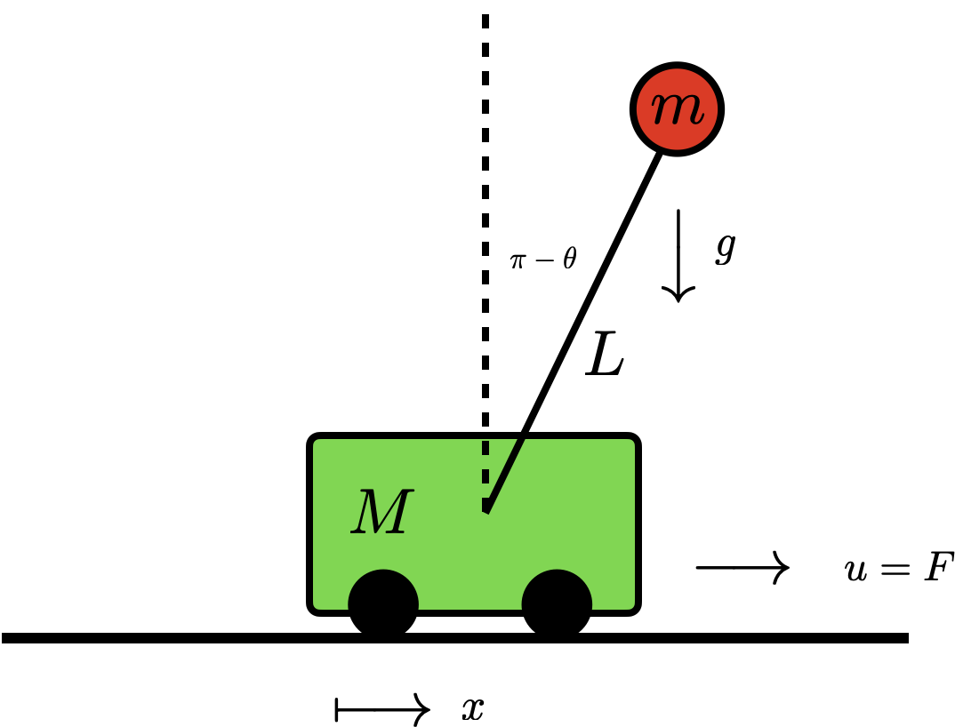

Figure 1. Schematic of inverted pendulum on a cart.

The inverted pendulum on a moving cart system shown in figure 1 is used in multiple applications as moving heavy objects, robot manipulators just to name a few. The only deriving force for this system is the force affecting the cart. There are two fixed points, corresponding to either the pendulum down (stable) or pendulum up (unstable) configuration; in both cases the angular and linear velocity of the pendulum are zeros. The **goal** is to derive the pendulum to the unstable configuration. To do so you must:

1. Derive the full nonlinear dynamics of the system.
2. Linearize the equations around the unstable fixed point (pendulum up configuration i.e., $θ={90}^{o}$).
3. Either use Laplace domain or the time domain to analyze the system response by analyzing the:
   1. Force free motion (i.e., only excite the system by different initial conditions).
   2. The step/ramp/parabolic response of the system under different initial conditions.
4. Use any of the proposed controllers to derive the pendulum to the unstable configuration:
   1. LQR
   2. MPC
   3. PID along with genetic algorithms to tune the PID gains.

# Project

1. System Modeling:
   * Develop a mathematical model of the system using first principles.
2. Controller Design:
   * Choose a control strategy from the proposed schemes.
   * Design the controller gains based on the system model and desired performance criteria, such as stability and response time.
3. Software implementation:
   * Use MATLAB to simulate the system and to implement the control algorithm in simulation.
4. Documentation and Presentation:
   * Document your work in a report summarizing the project, including the system modelling, controller design, and results analysis.
   * Make a presentation to discuss the project and present the results to the class.